SOP Title | Negative, Large Movement & Job Loss Report
Version Number | 2
Created by | Renuka Priyadarshani
Updated on | 04/06/2025
Approved by | Jason Pretorius

- Objective
The purpose of this procedure is to recognise job losses, excess profits or negative margins transferred to P&L & ensure all costs are billed out and accrued in the job.

- Scope
This procedure applies to all Operations and Finance.

- Responsibilities:
CFO
- Responsible to review and approve this procedure.
Finance Manager
- Ensure all staff have the relevant training and are deemed competent for the tasks they are completing.
- Advise all staff and management of any changes made to the accepted process prior to the change being implemented.
- Provide facilitator access to all relevant documentation.
Finance Department
- to follow the procedure
- to raise any issues with the manager

- Competency and training requirements
The person performing the procedure must have received training, and training records must be kept.
The person carrying out the procedure must ensure that all admin invoices are correctly uploaded and approved via M-files for payments.
- Terminology
Terminology | Definition
NRC | Non-Recoverable Costs
Negative P&L Movement | jobs that have realized negative job profit margins less than -$250 within a reporting period.
Large P&L Movement | jobs that have realized excess job profits greater than $5,000 within a reporting period.
Job Losses | Jobs closed during the period that have resulted in a net loss greater than $100 over the life of the job.

- Equipment / Software
- Cargowise

- Other Relevant Documentation
- Cargowise Reports

- Steps:
Negative & Large Movements:
1(a). Run the Job Profit Forwarding report located in CW1 --> Manage--> Job Costing>Reports>Job Profit - Forwarding
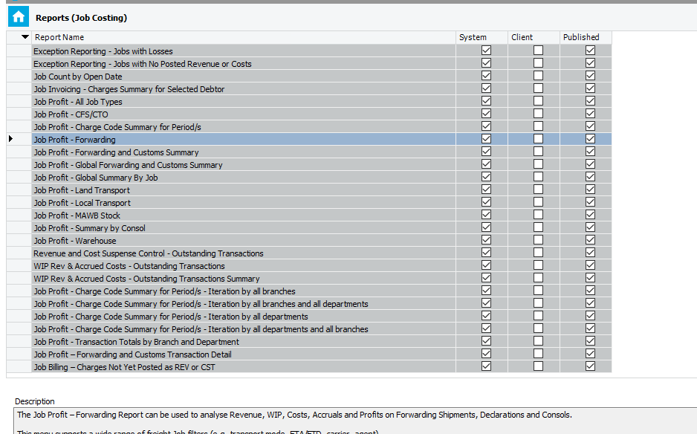
2(a). Make the below changes to the primary filters in this report:
- Configuration – Accounts
- Transaction Recognised - Reporting period date range. E.g., If reporting month is October - From 01/10/20 To 31/10/20
-Active Status – Select “All”
Optional Templates - Tick summary by Job

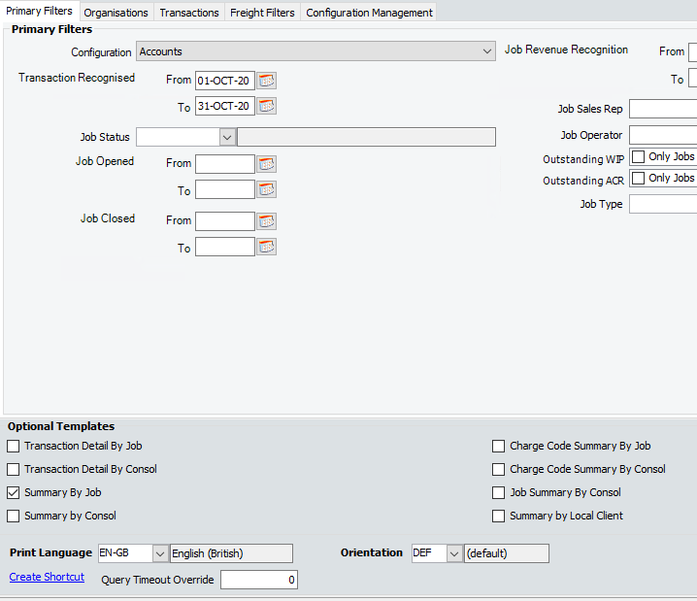
3(a). Click on Preview --> Open in Excel
Remove the total sums for columns P to T in the data file.

4(a). Create a duplicate Excel summary by Job report, and onto the duplicate, sort the same by ascending order (smallest to largest) in terms of “Job profit”

Delete all jobs which are greater than Job Profit < (250) and delete all jobs that are outside of the range “AUD 0 < X < AUD 5000”

Copy and move the resulting table into a new tab on the same Excel sheet, and name one
1. Negative Margin > $250 (In same, delete all Jobs with > $5000)
2. Excess Profits > $5000 (In same, delete all Jobs with > $250)

Job Loss Report
1(b). Run the Jobs with losses greater than $100 located in CW1 --> Manage--> Job Costing--> Reports --> Exception Reporting - Jobs with losses.
2(b). Make the below changes to the primary filters in this report:
- Configuration – Accounts
- Job Closed - Reporting period date range. Eg: If reporting month is October - From 01/10/20 To 31/10/20.
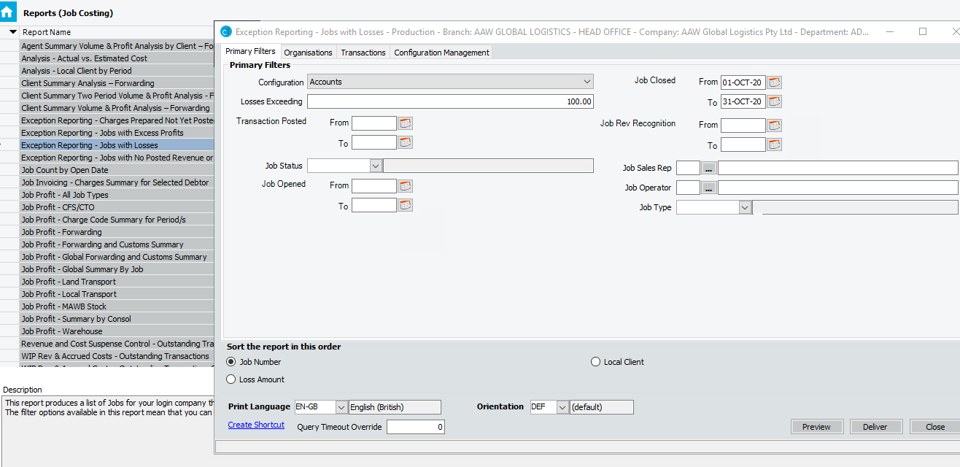
3(b). Click on Preview --> Open in Excel
4(b). Copy & paste or Copy and Move the table in it’s entirety into the “Negative Movement, Excess profit and Job Loss report”, into a new tab named “Job Loss report”.
NB – for AAW Global Logistics AU, the branches can be covered in this manner.
For Coastalbridge (CBG) this report must be run by login to CW1’s CBG environment and running the report.
For RSS, the report must be downloaded and the same process conducted – however Mildura and PILLA branches must be run separately.

This overall report with the 3 tabs is the Masterfile.
5. The Masterfile should be saved into the following link
C:\Users\mepaac5\GMS ONLINE\AAW Finance - Documents\Renuka\AAS - Management Reports\P&L STATEMENT 2024.25\Control Report
NB – this Report must be created Monthly, hence each Month’s report must have a new File.
Sort the 3 tabs of the Report, based on the Branch (alphabetical order from A----Z), and leave an empty row after each branch.

6. Next to find the Negative movements relating to each branch.
A) The previous month’s report is copy-pasted into a new folder, renamed to the current Month.
B) The date of all 3 tabs must be updated.
C) The data of the previous month must be deleted, the current month’s data taken and copy pasted into the data file.
This process must be repeated into the 3 tabs (3 different reports) and each different branch.

5. the relevant Branch code represented by B5 cell is linked to the B5 cell in the Branch_(-) Margins > $250 tab and does not require updating.
6. Refresh the filter on the Job Profit column in Branch_Jobs with Losses tab.
- Once updated, refresh and run the Branch (-) Margin > $250, Branch Excess profit > $5,000 & Branch job with losses (green and purple tabs) for each branch by updating the B5 cell, and create a copy of these three tabs and save the file under each Branch’s P&L folder in F Drive:
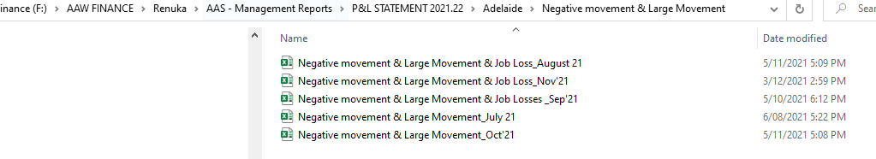
- Remove the formulas, blank rows, and the check cells in the copied file prior to email distribution.
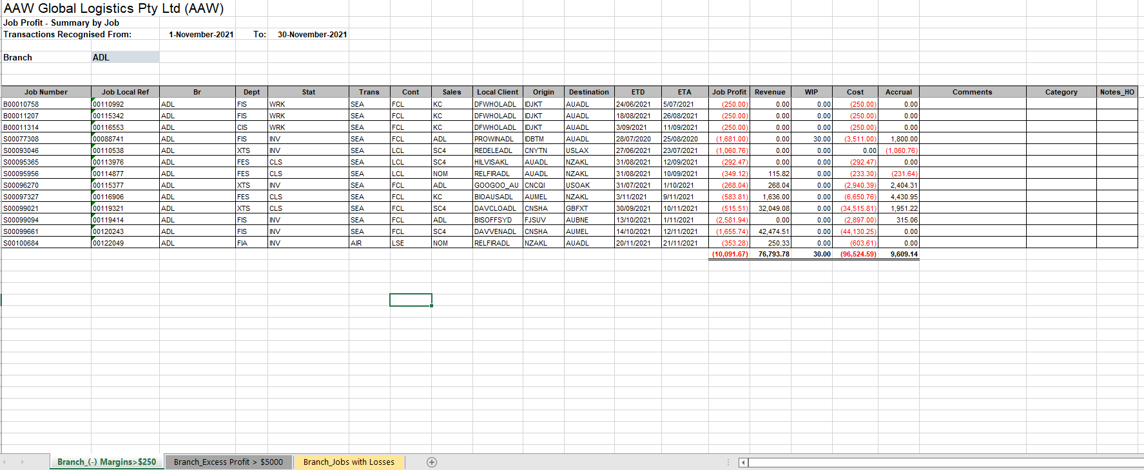

- Email the file to the respective branches requesting for commentary on the excess job movements & job losses by WD08:
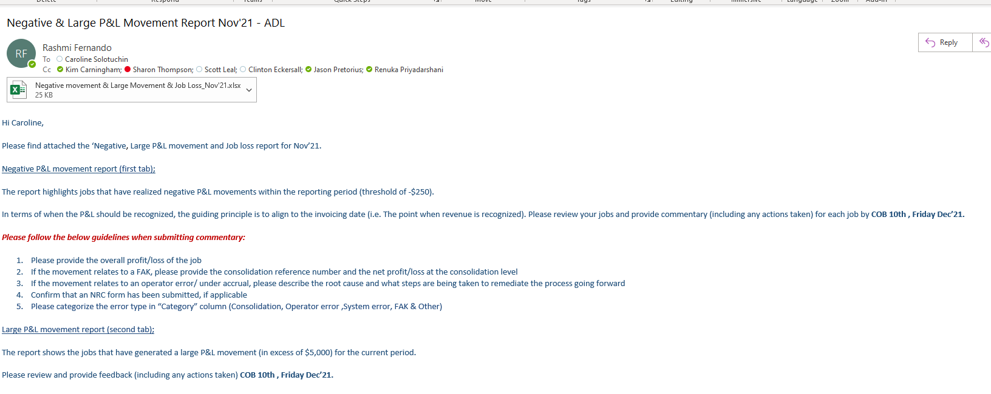
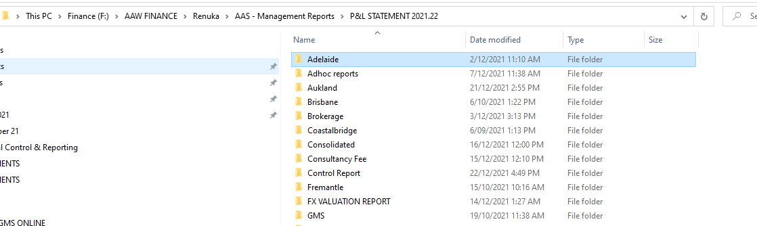
- Action any branch commentary e.g., approved NRC Forms) and save the email correspondence in the respective branch folder in the F drive.

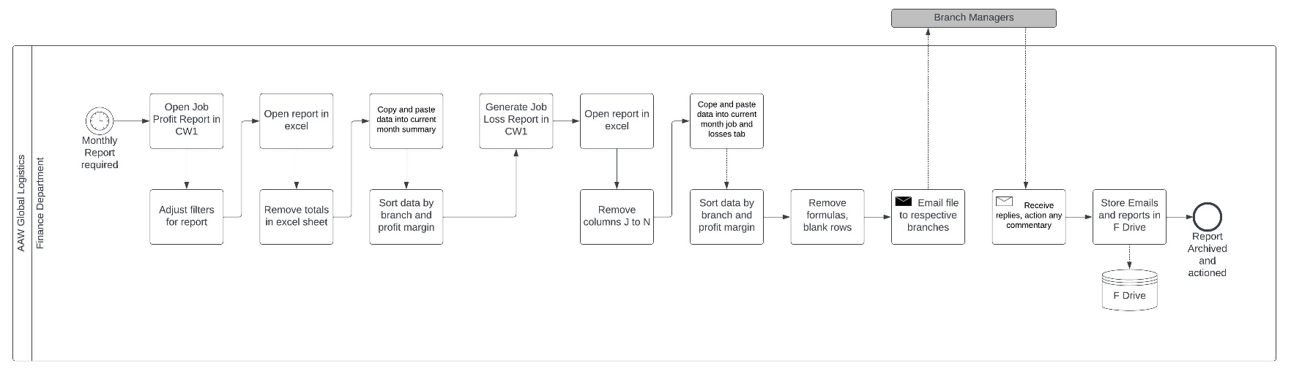
- Process Map

_

